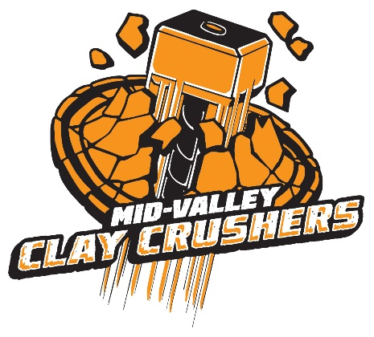
Crushin’ Clays for Days!

Mid-Valley Clay Crushers invites you to our 2 Day Spring Tournament!
@
Mid-Valley Clays
6181 Concomly Rd NE
Gervais, OR 97026
Club House Phone (503) 792-3431
www.midvalleyclays.com

March 23 & 24
23th: Trap and Skeet
24th: Sporting Clays
100 Rounds per Event

Shooting begins PROMPTLY
at 8:30am Saturday 3/23 and 9:30am Sunday 3/24
Registration opens at 7am on Saturday and 8:30am Sunday

Youth Team Members eligible for Awards; placing 1st-3rd in each division and event.
ORYESS recognizes the divisions as follows:
- Rookie (First year athlete)
- Junior: 6th through 8th grades
- Senior: 9th through 12th grades
- College: Freshman through Senior
PLEASE Pre-Register by
email at ltgrauer@gmail.com or call/text 503-435-9229

- Ladies
Limited Overnight Camping
Contact Mid-Valley (503) 792-3431
Food Available for Purchase from
S & S Outpost Grill
Games for Raffle Tickets Flurry~Jenga~Cornhole
$100 for all 3 Events
Cash or Check Only
Payable to Mid-Valley Clay Crushers

Or you can register by event:
Trap $30~ Skeet $30~ Sporting $40
Friends & Families can register to participate in Sporting Clays $42

